Purpose of this Form
San Diego Fire Relief Association (SDFRA) provides assistance to your dependents/survivors and this form is used to identify
and designate who would receive payment(s) if a death benefit claim is approved. Benefits are paid to survivors according to the following criteria:

-Individual designated on this form.

*This form may be updated at any time as determined necessary by the member. Only the most currently completed, dated form in
the possession of SDFRA at the time of death shall be considered for payment thereby replacing all prior forms in entirety.

Authorization and Designation
This form is for use in declaring a beneficiary for any SDFRA benefits that your dependents/survivors may be eligible for in the event of your death.

I, ____________________________________ (Full Name), as a member of San Diego Fire Relief Association, hereby designate the following beneficiary(s) for SDFRA benefits that may be paid in the event of my death:
Name: | Address: | Relationship: | Percent:
 |  |  | %
 |  |  | %
 |  |  | %
 |  |  | %
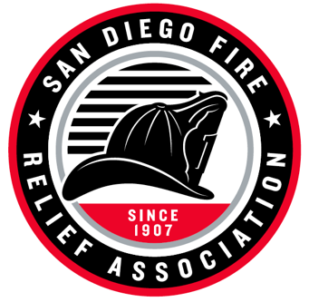

Member Signature: __________________________ Date: __________________________

Member ID: ________________________________ Electronically Filed by: _____________
Beneficiary Form
San Diego Fire Relief Association

10509 San Diego Mission Rd. Ste. F San Diego CA 92108

Phone (619)281-0354
Fax (619) 281-8325
mail@sdfra.org

